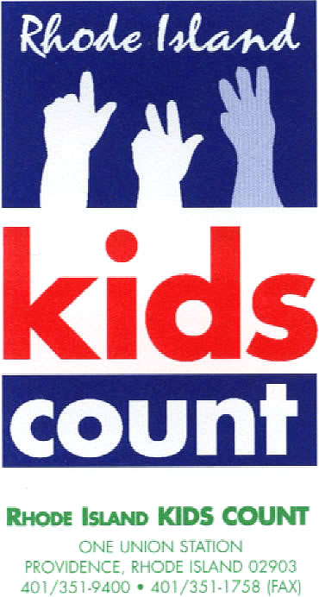
Contact: Katherine Linwood Chu, Communications Manager
401.351.9400, Ext. 22 / kchu@rikidscount.org
Join the conversation on Twitter: #EdChatRI and #SCLchat

Rhode Island KIDS COUNT Virtual Release

Policies and Practices Supporting
Student-Centered Learning in Rhode Island:
Youth, Family, and Community-Based Approaches to Equity in Education

Providence, RI (October 23, 2020) – Rhode Island KIDS COUNT will release its newest publication, Policies and Practices Supporting Student-Centered Learning in Rhode Island: Youth, Family, and Community-Based Approaches to Equity in Education, at a virtual policy roundtable on Monday, October 26, 2020 from 3:30 p.m. – 5:00 p.m. Featured speakers will include Elizabeth Burke Bryant, Executive Director of Rhode Island KIDS COUNT; Angélica M. Infante-Green, Commissioner of Elementary and Secondary Education; Deijah Prak, Youth member of Alliance of Rhode Island Southeast Asians for Education (ARISE); Sarai Mejia, Youth member of Youth In Action; Ramona Santos Torres, Executive Director of Parents Leading for Educational Equity; Christine Arouth, Director of Newport Family Child Opportunity Zone; Jan Mermin, 21st Century Community Learning Center Manager & Expanded Learning Opportunity Specialist at the Rhode Island Department of Education; and Elliot Rivera, Executive Director of Youth In Action. Senior Policy Analyst Paige Clausius-Parks will facilitate the discussion and share findings from the publication. To join the event on Monday, please use the following Zoom link: https://us02web.zoom.us/webinar/register/WN_wS0bIgVSQQmmTWBDH4HH5g.

The Rhode Island public education system has been plagued by racism since its founding in the early 1800s, and the inequities that developed as a result continue to be one of Rhode Island’s greatest challenges. Youth voice, family engagement, mental and behavioral health supports, expanded learning opportunities, and student-centered instruction all have a positive impact on student outcomes and when integrated into the design and implementation of schools can help address inequities in education based on race, ethnicity, and income. Creating policies and practices that are racially aware, that incorporate a whole child approach, and that recognize and address the cognitive impacts of trauma can help address equity. This new report provides recommendations on how schools can develop and sustain strong partnerships with students, families, and communities to promote excellent, equitable, and sustained school improvement efforts.

“Good policies and practices are centered on the expertise and experiences of those most impacted," said Paige Clausius-Parks, Rhode Island KIDS COUNT Senior Policy Analyst. "Schools cannot meet the needs of students and overcome inequities caused by longstanding systemic racism without putting the voices and leadership of youth and families of color and community-based organizations at the center. Continuing to use adult-centered and White-focused understanding of racial disparities will not decrease inequities and may exacerbate them.”

Lessons From the COVID-19 Pandemic
Nationally and in Rhode Island, the COVID-19 pandemic is likely to exacerbate unacceptable and persistent inequities in education. Students that will fare the best during the pandemic and the combination of in-person, distance learning, and hybrid models will be those who attend
schools that prioritize healthy student-teacher relationships, provide clear, consistent, and linguistically appropriate communications with families, and foster positive partnerships with community-based organizations. The pandemic has demonstrated that students, families, communities, schools, and the economic stability of Rhode Island are mutually interdependent.
Scalable and substantial institutional change is needed, and schools cannot meet the needs of students and overcome inequities caused by longstanding systemic racism, bias, and discrimination without putting the voices and leadership of youth, families, and community-based organizations at the center of education policies and practices.

Youth Voice
Many schools fail to provide culturally responsive curricula or to employ educators of color who reflect the identities of students. Many schools impose disciplinary practices that disproportionately impact students of color, creating negative school climates and large barriers to reducing inequities. Often, efforts to close wide and unacceptable inequities in schools have been based on an adult-centered understanding of equity and do not authentically center the voices of youth.

"I feel as a Southeast Asian American of color with disabilities, things are kinda a mix of different ups and downs," said Akyla Proeung, ARISE youth member. "The school tries to portray a diverse community, but lacks the support students of color need. It’s always difficult to find a place where we can feel valued, as it is hard to bypass the racism in our schools."

"As an African American student, I feel like (most) staff feel like they can treat us anyway because we are in a lower income community compared to their white communities," said Fatima Anne, ARISE youth member. "There are times when we need a counselor and there’s no one to be found because the two we have are always booked up. One is always at the middle school and the other is trying to figure out how to deal with the 200 students who do know that she’s there."

Youth-led Empowerment Organizations
Several youth empowerment organizations in Providence are working to improve the education system for youth of color by providing wholistic programming that includes the study of power, race, class, sexual orientation, gender identity, and gender expression, and how these identities are reflected in youth experiences in their schools and communities. The Alliance of Rhode Island Southeast Asians for Education (ARISE), Providence Student Union (PSU), Youth In Action (YIA), Youth Pride, Inc. (YPI), and Young Voices provide youth with opportunities to develop public speaking skills, exercise leadership, gain critical and strategic thinking skills, mobilize their peers, and become civic leaders and global thinkers. These culturally responsive organizations use an interdisciplinary approach to youth empowerment and civic education including reading of primary texts, data, budgets, policies and writing of speeches, testimonies, and opinion articles while also providing tutoring services, college and career preparation, social-emotional supports, outreach to families, and referrals to social services.

"Youth leadership organizations provide platforms for youth to do more, be prepared to do more and not be afraid to do more,” said Sarai Mejia, youth member, Youth In Action.

"Youth leadership orgs like Youth In Action are a necessary piece of the education and development of young people,” said Elliot Rivera, Executive Director, Youth In Action. “The academic rigor of leadership programming like ours provides for youth the necessary skill sets to be complete, well rounded adults while practicing those skills as well. Being able to provide that from an outside perspective creates a holistic education for youth to see and understand inequities. They're then provided the tools to leverage their own and collective power to make better systems for themselves and the next generation."

Family Engagement
The level of family involvement and engagement in schools is directly related to the quality of the relationships built between families and educators, school personnel, and administrators.
Equitable collaboration between families and schools is characterized by a reciprocal partnership in which families and schools emphasize relationship-building, work together to develop goals, co-develop a strategy for achieving student success, and include parents as experts on their own children.

“Those in positions of power who say they value the voices of families and students must work intentionally and diligently to create spaces where we feel our voices, experiences and input truly mean something for them," said Ramona Santos Torres, Co-Founder & Executive Director of Parents Leading for Educational Equity (PLEE). "We have to move towards concrete solution-oriented models of action that will start to create the changes all of us want to see in our education system.”

Community-Based Organizations
Decades of disinvestment in low-income communities have created gaps between the needs of students and the availability of resources and services to address those needs. Community-based organizations are often entrusted frontline providers of crucial services that close the gap between resources and needs unmet by schools and government agencies. Out-of-school time programs can contribute significantly to children’s development and learning. High-quality, organized afterschool and summer programs improve the supervision and safety of youth, promote positive social skills, and, with sufficient dosage, improve student achievement. Quality out-of-school time programs provide engaging activities that are intentionally designed to promote youth development and are taught by trained, dedicated instructors who work effectively with youth. Youth who participate consistently can show improved competence, caring, and connections.

A full set of action items is included in this report.

###
Rhode Island KIDS COUNT is a statewide children’s policy organization that works to improve the health, economic well-being, safety, education, and development of Rhode Island children.

